**Data Visualization & Engineering Mini Project**

|  |  |
| --- | --- |
| **Name** | **SAP ID** |
| Ananya Godse | 60009220161 |
| Dhruvi Mehta | 60009220204 |
| Richa Patel | 60009230202 |
| Asma Shaikh | 60009230209 |

**Topic:** College Students’ Food Preferences

**Dashboard:**

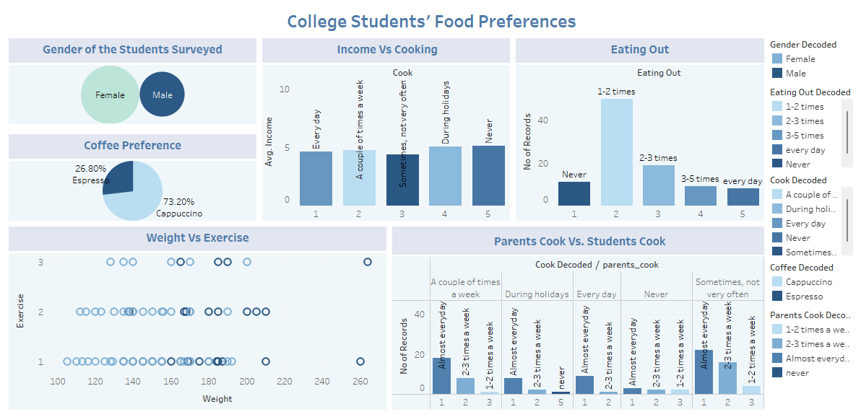

**Story:**

